08 – Tuple/Set

Dept of Artificial Intelligence and Machine Learning | Rajalakshmi Engineering College

. 104

Ex. No. : 8.1 Date: 27/4/24

Register No.: 231501058 Name: M Harish

Binary String

Coders here is a simple task for you, Given string str. Your task is to check whether it is a binary string or not by using python set.

Examples:

Input: str = "01010101010"

Output: Yes

Input: str = "REC101"

Output: No

For example:
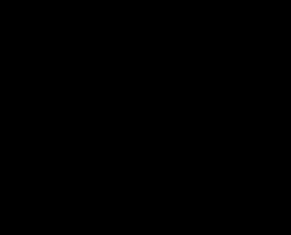
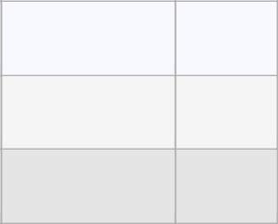

Input

Result

01010101010

Yes

010101 10101

No

PROGRAM

str=input()

str=[x for x in str]

str=set(str)

c=0

if '0' in str and '1' in str:

c+=2

if(c==len(str)):

print("Yes")

else:

print("No")

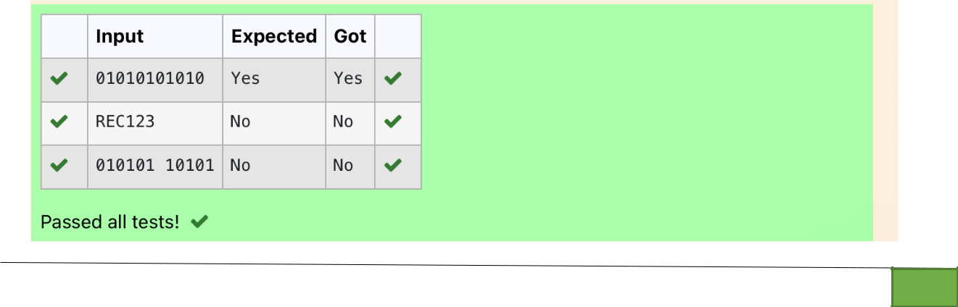

Dept of Artificial Intelligence and Machine Learning | Rajalakshmi Engineering College

. 105

Ex. No. : 8.2 Date: 27/4/24

Register No.: 231501058 Name: M Harish

Check Pair

Given a tuple and a positive integer k, the task is to find the count of distinct pairs in the tuple whose sum is equal to K.

Examples:

Input: t = (5, 6, 5, 7, 7, 8 ), K = 13

Output: 2

Explanation:

Pairs with sum K( = 13) are {(5, 8), (6, 7), (6, 7)}.

Therefore, distinct pairs with sum K( = 13) are { (5, 8), (6, 7) }.

Therefore, the required output is 2.

For example:
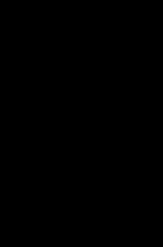
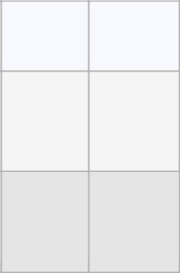

Input | Result
1,2,1,2,5 | 1
3

1,2 | 0
0

PROGRAM

s=input()

l1=s.split(',')

n=int(input())

l2=[]

for i in range(len(l1)):

j=i+1

for j in range(len(l1)):

if(int(l1[i])+int(l1[j])==n):

l2.append(list[l1[i],l1[j]])

s=set(l2)

print(len(s)//2)

Dept of Artificial Intelligence and Machine Learning | Rajalakshmi Engineering College

. 106

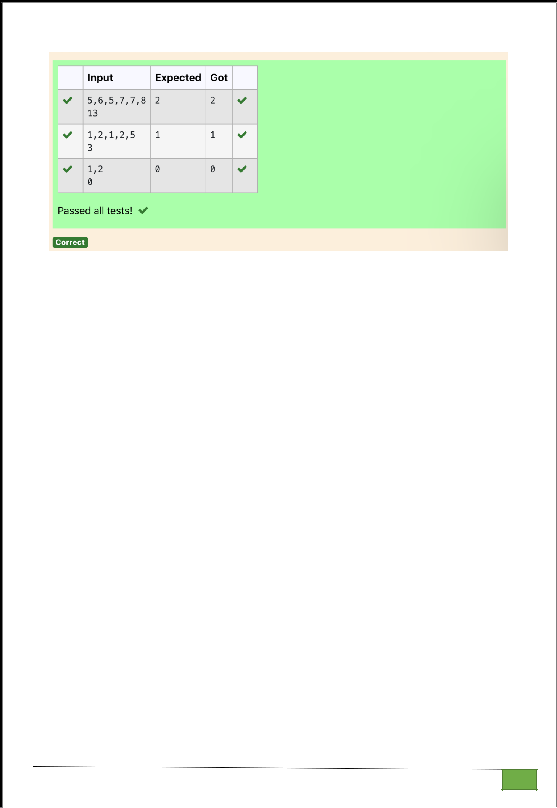

Dept of Artificial Intelligence and Machine Learning | Rajalakshmi Engineering College

. 107

Ex. No. : 8.3 Date: 27/4/24

Register No.: 231501058 Name: M Harish

DNA Sequence

The DNA sequence is composed of a series of nucleotides abbreviated as 'A', 'C', 'G', and 'T'.

For example, "ACGAATTCCG" is a DNA sequence.

When studying DNA, it is useful to identify repeated sequences within the DNA.

Given a string s that represents a DNA sequence, return all the 10-letter-long sequences (substrings) that occur more than once in a DNA molecule. You may return the answer in any order.

Example 1:

Input: s = "AAAAACCCCCAAAAACCCCCCAAAAAGGGTTT"
Output: ["AAAAACCCCC","CCCCCAAAAA"]
Example 2:

Input: s = "AAAAAAAAAAAAA"
Output: ["AAAAAAAAAA"]
For example:

Input |  | Result

AAAAACCCCCAAAAACCCCCCAAAAAGGGTTT AAAAACCCCC
CCCCCAAAAA

PROGRAM

s = input()

sequence_length = 10

seen = {}

result = []

for i in range(len(s) - sequence_length + 1):

sequence = s[i:i + sequence_length]

if sequence in seen:

seen[sequence] += 1

else:

seen[sequence] = 1

for sequence, count in seen.items():

if count > 1:

result.append(sequence)

for i in result:

print(i)

Dept of Artificial Intelligence and Machine Learning | Rajalakshmi Engineering College

. 108

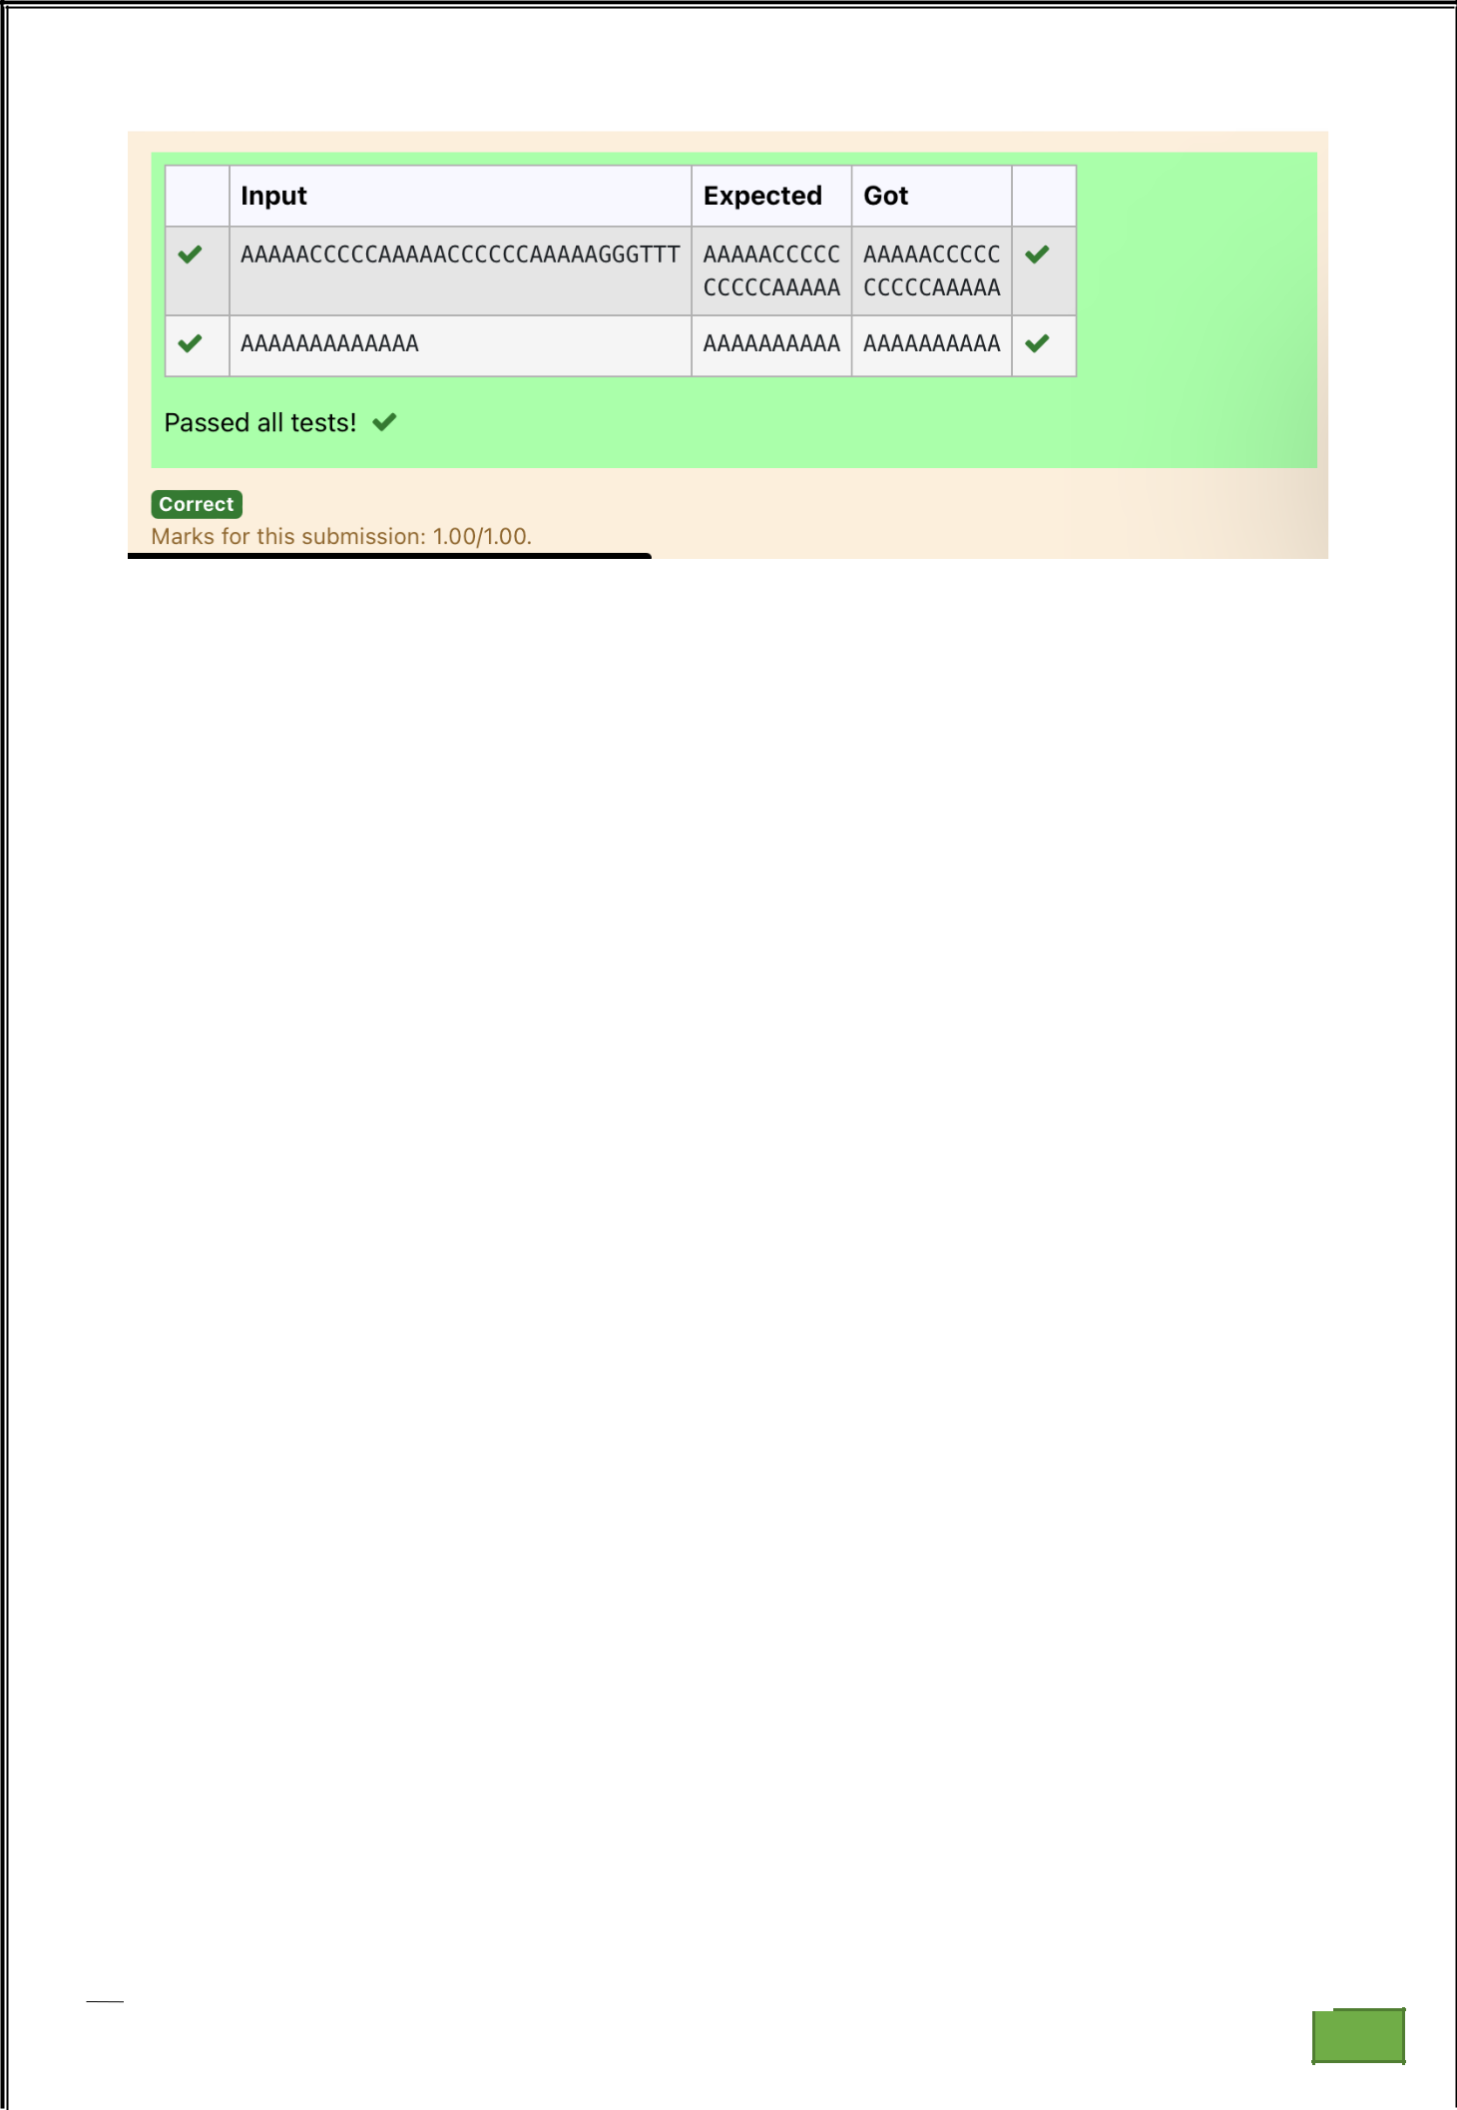

Dept of Artificial Intelligence and Machine Learning | Rajalakshmi Engineering College

. 109

Ex. No. : 8.4 Date: 27/4/24

Register No.: 231501058 Name: M Harish

Print repeated no

Given an array of integers nums containing n + 1 integers where each integer is in the range [1, n] inclusive.There is only one repeated number in nums, return this repeated number. Solve the problem using set.

Example 1:

Input: nums = [1,3,4,2,2]
Output: 2
Example 2:

Input: nums = [3,1,3,4,2]
Output: 3

For example:
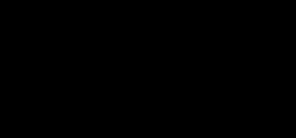
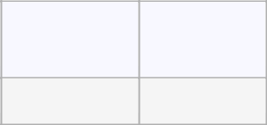

Input

Result

13442

4

PROGRAM

st=input()

nums=st.split()

for i in nums:

if nums.count(i)==2:

b=nums.index(i)

print(nums[b])

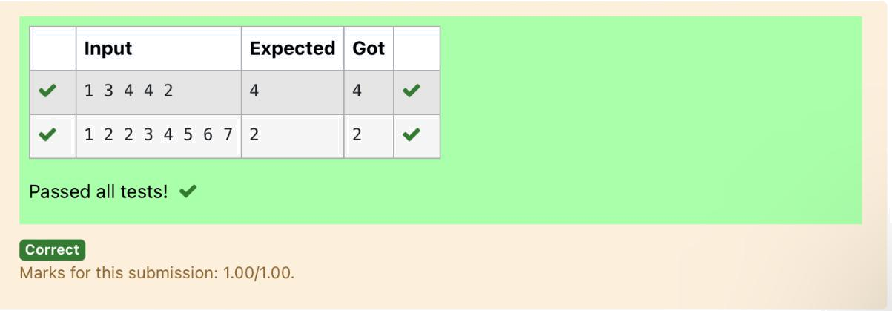

Dept of Artificial Intelligence and Machine Learning | Rajalakshmi Engineering College

. 110

Ex. No. : 8.5 Date: 27/4/24

Register No.: 231501058 Name: M Harish

Remove repeated

Write a program to eliminate the common elements in the given 2 arrays and print only the non-repeating elements and the total number of such non-repeating elements.

Input Format:

The first line contains space-separated values, denoting the size of the two arrays in integer format respectively.

The next two lines contain the space-separated integer arrays to be compared.

Sample Input:

5 4

12865

26810

Sample Output:

1510

3
For example:

Input | Result
5 4 | 1510
12865 | 3
26810
PROGRAM

sizes = list(map(int, input().split()))

arr1 = list(map(int, input().split()))

arr2 = list(map(int, input().split()))

set1 = set(arr1)

set2 = set(arr2)

unique1 = set1 - set2

unique2 = set2 - set1

unique_elements = list(unique1) + list(unique2)

if unique_elements:

print(" ".join(map(str, unique_elements)))

print(len(unique_elements))

else:

print("NO SUCH ELEMENTS")

Dept of Artificial Intelligence and Machine Learning | Rajalakshmi Engineering College

. 111

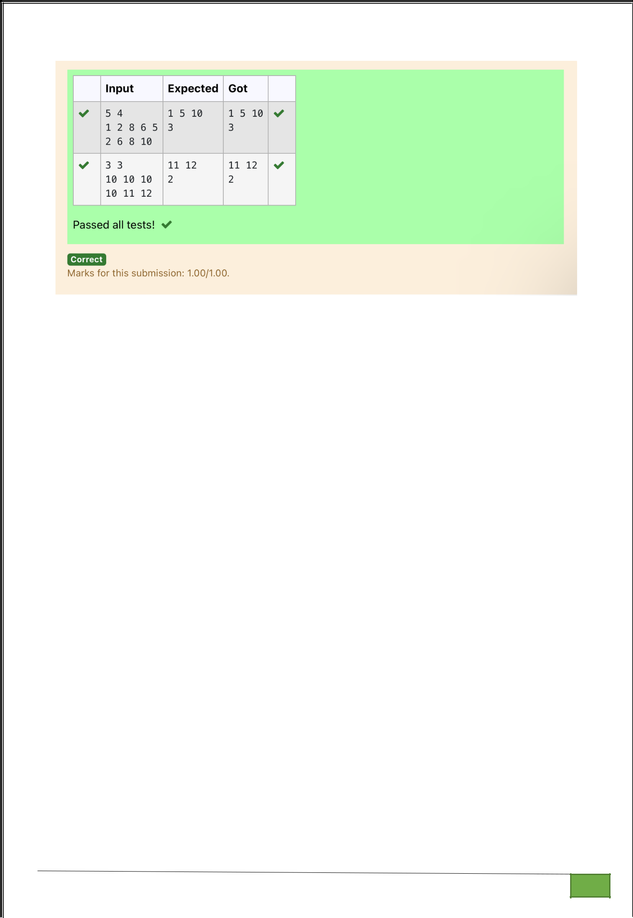

Dept of Artificial Intelligence and Machine Learning | Rajalakshmi Engineering College

. 112

Ex. No.

:
8.6
Date: 27/4/24

Register No.: 231501058

Name: M Harish

Malfunctioning Keyboard

There is a malfunctioning keyboard where some letter keys do not work. All other keys on the keyboard work properly.

Given a string text of words separated by a single space (no leading or trailing spaces) and a string brokenLetters of all distinct letter keys that are broken, return the number of words in text you can fully type using this keyboard.

Example 1:

Input: text = "hello world", brokenLetters = "ad"

Output:

1

Explanation: We cannot type "world" because the 'd' key is broken.

For example:
Input | Result
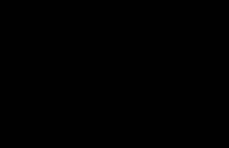
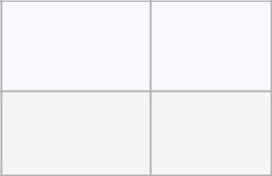

hello world | 1
ad

PROGRAM

s1=str(input())

s2=str(input())

l1=(s1.lower()).split(' ')

l2=list(s2)

for i in l2:

for word in l1:

if i in list(word):

l1.remove(word)

print(len(l1))

Dept of Artificial Intelligence and Machine Learning | Rajalakshmi Engineering College | . 113

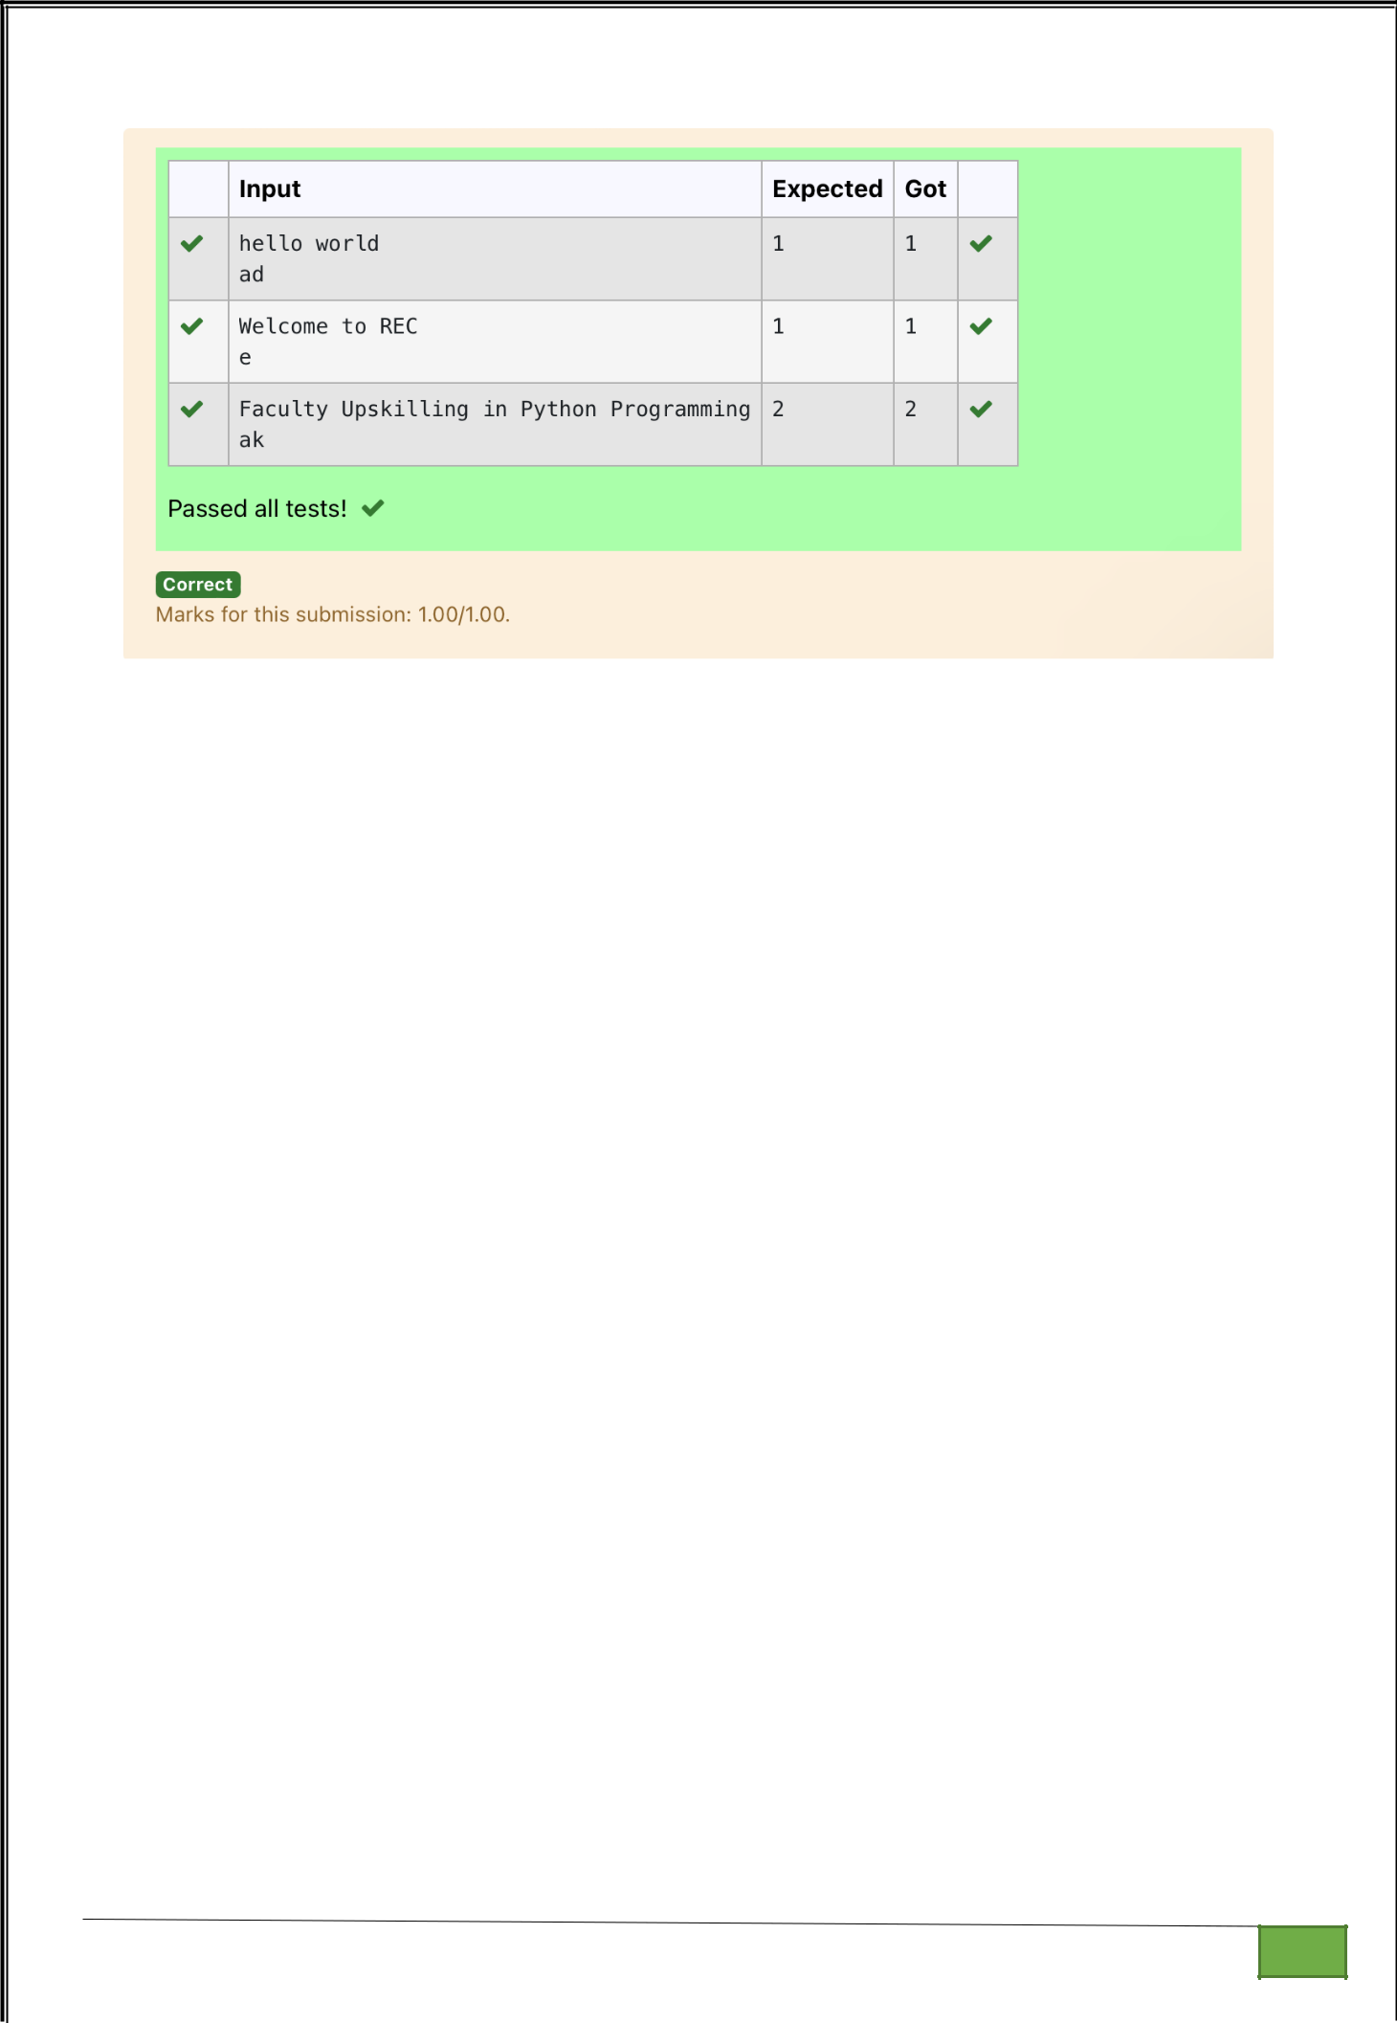

Dept of Artificial Intelligence and Machine Learning | Rajalakshmi Engineering College

. 114

Ex. No.

:
8.7
Date: 27/4/24

Register No.: 231501058

Name: M Harish

American keyboard

Given an array of strings words, return the words that can be typed using letters of the alphabet on only one row of American keyboard like the image below.

In the American keyboard:

- the first row consists of the characters "qwertyuiop",
- the second row consists of the characters "asdfghjkl", and

- the third row consists of the characters "zxcvbnm".

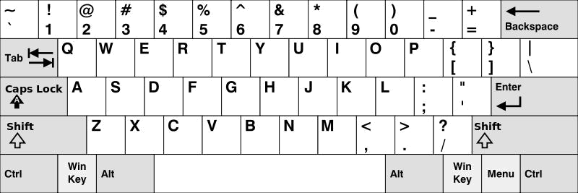

Example 1:

Input: words = ["Hello","Alaska","Dad","Peace"]
Output: ["Alaska","Dad"]
Example 2:

Input: words = ["omk"]
Output: []
Example 3:

Input: words = ["adsdf","sfd"]
Output: ["adsdf","sfd"]

Dept of Artificial Intelligence and Machine Learning | Rajalakshmi Engineering College | . 115

For example:
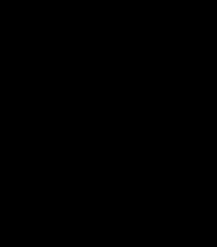
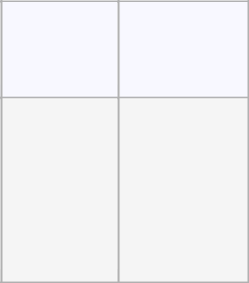

Input Result

4
Hello

Alaska

Dad

Peace

Alaska

Dad

PROGRAM

n=int(input())

l=[]

for j in range(n):

l.append(str(input()))

row1 = set("qwertyuiop")

row2 = set("asdfghjkl")

row3 = set("zxcvbnm")

result = []

for word in l:

lower_word = set(word.lower())

if lower_word <= row1 or lower_word <= row2 or lower_word <= row3:

result.append(word)

if(len(result)!=0):

for i in range(len(result)):

print(result[i])

else:

print("No words")

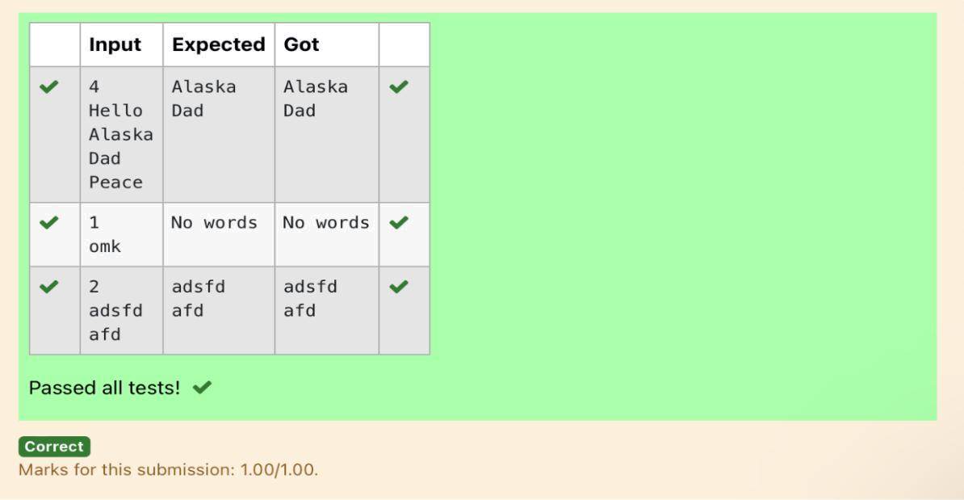

Dept of Artificial Intelligence and Machine Learning | Rajalakshmi Engineering College | . 116

